WEEK 3 — STATISTICAL ANALYSIS AND HYPOTHESIS TESTING

Indian E-Commerce Sales Analytics Dataset
Internship: Yuva Intern – Virtual Data Science with Python Apprentice Intern
Source: Kaggle
Tools: Python, Jupyter Notebook, Pandas, Matplotlib, Seaborn, Squarify

1. Introduction
Statistical analysis helps transform raw data into meaningful and reliable conclusions. While descriptive analysis helps us understand patterns and trends in the dataset, hypothesis testing allows us to determine whether an observed difference or relationship is statistically significant or may have occurred by chance.
In this week, statistical techniques were applied to the Indian E-Commerce Sales Analytics dataset to study customer spending behaviour, payment methods, order outcomes, customer tiers, and coupon usage. Four business-oriented hypotheses were formulated and tested using an Independent t-test, Chi-Square test, and One-Way ANOVA. A significance level of α = 0.05 was used throughout the analysis.
For each hypothesis, a Null Hypothesis (H₀) and an Alternative Hypothesis (H₁) were defined. The p-value obtained from each statistical test was compared with 0.05 to determine whether H₀ should be rejected or not rejected. Effect sizes were also considered wherever appropriate to understand the practical importance of the findings.

2. Dataset Overview
The analysis continued with the Indian E-Commerce Sales Analytics Dataset used in the previous weeks. The dataset consists of three main files:
Dataset | Records | Columns
Customers | 40,000 | 15
Products | 2,000 | 12
Sales | 249,995 | 22

Data Preparation
Before conducting the statistical tests, the following preprocessing steps were applied:
- Date fields were converted into the appropriate datetime format.
- Missing coupon values were replaced with "No Coupon".
- A Has_Review indicator was created from the rating information.
- Five records with negative Total_Amount values were removed.
- Customer information was merged with sales data for the customer-tier analysis.
The cleaned sales dataset containing 249,995 valid orders was used for the hypothesis testing process.

3. Hypothesis 1 — UPI vs COD Average Order Value

Research Question
Do customers using UPI have a higher average order value than customers using COD?

Hypotheses
H₀ (Null Hypothesis): There is no significant difference in the mean order value between UPI and COD users.
H₁ (Alternative Hypothesis): UPI users have a significantly higher mean order value than COD users.

Statistical Test
Independent Samples t-test
A Levene's test was first performed to check equality of variances. Since the variance assumption was not satisfied, the Welch version of the independent t-test was used.

Results
Metric | Result
UPI Orders | 128,471
COD Orders | 82,091
UPI Mean Order Value | ₹24,724.78
COD Mean Order Value | ₹22,437.40
t-statistic | 13.8704
p-value | < 0.001
95% CI for Mean Difference | ₹1,964.15 to ₹2,610.60

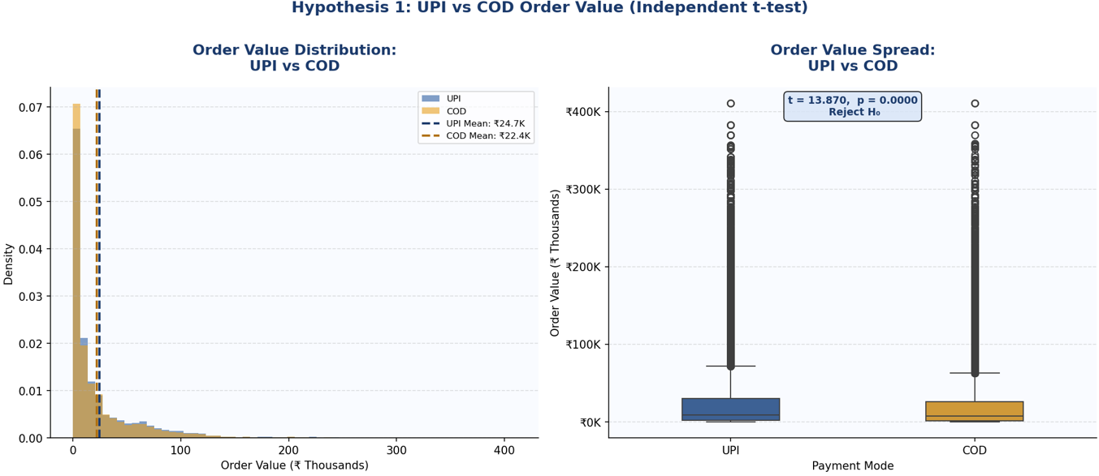
Visualization
Figure 1: UPI vs COD Order Value Comparison
The visualization compares the distribution and spread of order values for UPI and COD customers using a distribution plot and box plot.

Interpretation
The test produced a p-value less than 0.001, which is below the significance level of 0.05. Therefore, the null hypothesis is rejected.
The average order value of UPI users was ₹24,724.78, while the average order value of COD users was ₹22,437.40. This represents an average difference of approximately ₹2,287.38 per order in favour of UPI users. The confidence interval for the difference was entirely positive, further supporting the finding that UPI users had higher average order values.

Business Implication
The results suggest that UPI customers tend to place higher-value orders. The business can encourage UPI adoption through cashback offers, loyalty rewards, small discounts, and a faster checkout process. Increasing digital payment adoption may help improve average order value while also providing customers with a convenient payment experience.

4. Hypothesis 2 — Order Status vs Payment Mode

Research Question
Is order status related to the payment mode selected by the customer?

Hypotheses
H₀ (Null Hypothesis): Order status is independent of payment mode.
H₁ (Alternative Hypothesis): Order status and payment mode are significantly associated.

Statistical Test
Chi-Square Test of Independence
The test was used to determine whether payment mode and order status are statistically related categorical variables.

Results
Metric | Result
Chi-Square Statistic | 10.1623
Degrees of Freedom | 12
p-value | 0.601724
Cramér's V | 0.0037
Decision | Fail to Reject H₀

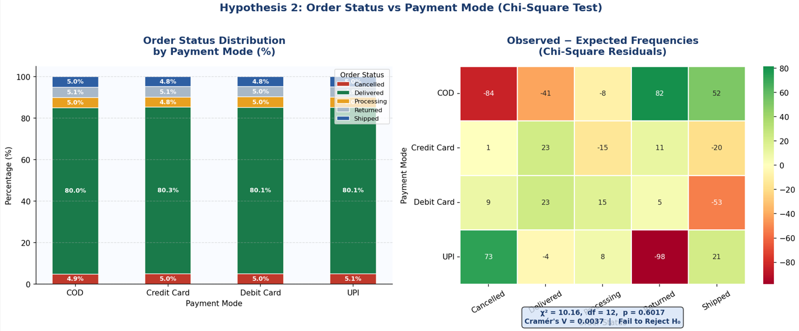
Visualization
Figure 2: Order Status Distribution by Payment Mode
The stacked percentage chart shows the distribution of Delivered, Cancelled, Returned, Shipped, and Processing orders across different payment modes.

Interpretation
The p-value of 0.6017 is greater than 0.05. Therefore, the null hypothesis is not rejected.
This means there is no statistically significant association between payment mode and order status in the dataset. Cramér's V of 0.0037 also indicates an extremely weak relationship. The distribution of order outcomes is broadly similar across UPI, COD, debit card, and credit card transactions.

Business Implication
Payment mode does not appear to be a major factor influencing delivery, cancellation, or return outcomes. Therefore, the business should focus on operational factors such as inventory management, order processing, logistics, delivery performance, and customer service to improve order fulfilment rather than relying on payment-mode changes.

5. Hypothesis 3 — Order Value Across Customer Tiers

Research Question
Does average order value differ significantly among Silver, Gold, and Platinum customers?

Hypotheses
H₀ (Null Hypothesis): The mean order value is equal across Silver, Gold, and Platinum customer tiers.
H₁ (Alternative Hypothesis): At least one customer tier has a significantly different mean order value.

Statistical Test
One-Way ANOVA
Since three customer groups were compared, a one-way ANOVA was used. After obtaining a significant ANOVA result, Tukey HSD post-hoc testing was performed to identify which specific customer tiers differed.

Results
Customer Tier | Orders | Mean Order Value | Standard Deviation
Silver | 25,359 | ₹7,372.33 | ₹19,055.66
Gold | 37,063 | ₹10,831.44 | ₹18,943.22
Platinum | 187,573 | ₹28,481.14 | ₹40,490.58

ANOVA Results
Metric | Result
F-statistic | 6508.9885
p-value | < 0.001
Eta-squared | 0.0495
Effect Size | Medium
Decision | Reject H₀

Post-Hoc Result
The Tukey HSD test showed that all three customer-tier pairs differed significantly:
- Silver vs Gold — Significant
- Silver vs Platinum — Significant
- Gold vs Platinum — Significant

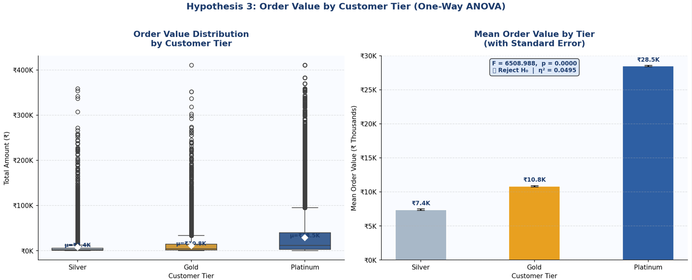
Visualization
Figure 3: Mean Order Value by Customer Tier
The visualization compares the distribution and average order value of Silver, Gold, and Platinum customers.

Interpretation
The ANOVA produced a p-value below 0.001, which is lower than the 0.05 significance level. Therefore, the null hypothesis is rejected.
The findings show a clear increase in average order value as customer tier increases. Platinum customers had the highest average order value at ₹28,481.14, followed by Gold customers at ₹10,831.44 and Silver customers at ₹7,372.33.
The Tukey HSD test confirmed that the differences between every pair of customer tiers were statistically significant. The eta-squared value of 0.0495 indicates a medium effect, showing that customer tier has meaningful practical importance in explaining order-value differences.

Business Implication
Customer tier is an important segmentation variable for the business. Platinum customers should receive greater attention through personalized recommendations, exclusive offers, loyalty rewards, premium services, and retention strategies because they generate substantially higher order values.
Silver and Gold customers can be targeted with cross-selling, upselling, personalized promotions, and tier-upgrade campaigns to encourage higher spending and strengthen customer loyalty.

6. Hypothesis 4 — Coupon Users vs Non-Coupon Users

Research Question
Do customers who use coupons have a higher average order value than customers who do not use coupons?

Hypotheses
H₀ (Null Hypothesis): There is no significant difference in mean order value between coupon users and non-coupon users.
H₁ (Alternative Hypothesis): Customers who use coupons have a significantly higher mean order value than customers who do not use coupons.

Statistical Test
Independent Samples t-test
Levene's test was first used to examine equality of variances. Since the variance assumption was not satisfied, the Welch independent t-test was used.

Results
Metric | Result
Coupon Orders | 50,180
No-Coupon Orders | 199,815
Coupon Mean Order Value | ₹23,061.68
No-Coupon Mean Order Value | ₹23,889.39
t-statistic | -4.5453
p-value | 0.000005
Mean Difference | -₹827.71
95% CI | -₹1,184.63 to -₹470.79
Cohen's d | -0.0222
Effect Size | Negligible
Decision | Reject H₀

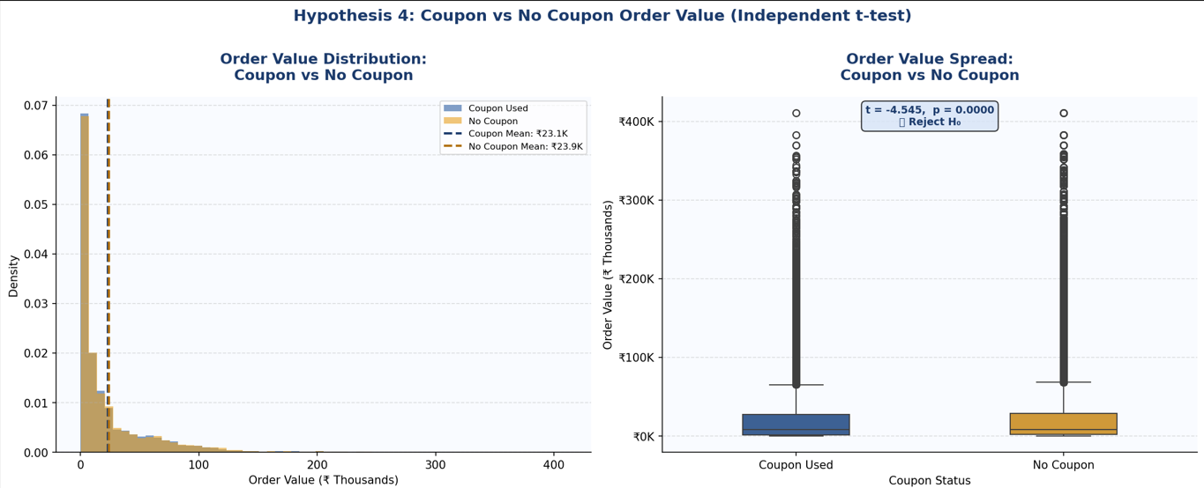
Visualization
Figure 4: Coupon vs No-Coupon Order Value Comparison
The visualization compares the distribution and spread of order values between customers who used coupons and those who did not.

Interpretation
The p-value of 0.000005 is much smaller than 0.05, so the null hypothesis is rejected. This indicates a statistically significant difference in average order value between the two groups.
However, the direction of the difference is opposite to the original hypothesis. Coupon users had an average order value of ₹23,061.68, while non-coupon users had an average order value of ₹23,889.39. Therefore, non-coupon users spent approximately ₹827.71 more per order on average.
Although this difference is statistically significant, the Cohen's d value of -0.0222 indicates a negligible effect size. This means that the actual practical difference in spending is very small.

Business Implication
The results indicate that coupons should not automatically be considered a method for increasing order value. Coupon campaigns may still be useful for customer acquisition, increasing purchase frequency, encouraging repeat purchases, or promoting selected products, but their success should be evaluated based on the specific business objective and return on investment.

7. Summary Table
Hypothesis | Statistical Test | Test Statistic | p-value | Decision | Key Finding
H1: UPI vs COD | Independent t-test | t = 13.8704 | < 0.001 | Reject H₀ | UPI users have a higher mean order value
H2: Payment Mode vs Order Status | Chi-Square | χ² = 10.1623 | 0.6017 | Fail to Reject H₀ | No significant association found
H3: Customer Tier | One-Way ANOVA | F = 6508.9885 | < 0.001 | Reject H₀ | Mean order values differ significantly across all tiers
H4: Coupon Usage | Independent t-test | t = -4.5453 | 0.000005 | Reject H₀ | Non-coupon users have a slightly higher mean; effect is negligible

Overall Statistical Findings
The analysis produced three major insights:
- UPI users have significantly higher average order values than COD users.
- Payment mode has no significant relationship with order status.
- Customer tier has a significant and practically meaningful relationship with order value.
- Coupon usage shows a statistically significant difference, but the practical effect is negligible and the difference favours non-coupon users.

8. Conclusion and Business Implications
The Week 3 statistical analysis provided deeper insights into customer and order behaviour in the Indian e-commerce dataset. The results demonstrate that statistical testing can help distinguish real patterns from differences that may simply occur due to random variation.
The analysis found that UPI users have significantly higher average order values than COD users, suggesting that promoting digital payment methods may support higher-value transactions. Customer tier was another important factor, with Platinum customers showing substantially higher order values than Gold and Silver customers. This highlights the importance of customer segmentation for loyalty, retention, and personalized marketing strategies.
On the other hand, payment mode was not significantly associated with order status. This suggests that delivery and cancellation performance should be addressed through operational areas such as inventory, logistics, processing time, and service quality rather than payment methods.
Coupon usage produced a statistically significant difference in order value, but the effect size was negligible. Therefore, discounts should not be assumed to increase basket size automatically. Coupon campaigns should instead be evaluated according to their intended purpose, such as customer acquisition, repeat purchases, product promotion, or increasing purchase frequency.
Overall, the findings show that statistical significance and practical significance should be considered together. A very small difference can become statistically significant when the sample size is large, but that does not necessarily mean the difference is important for business decisions. This analysis provides a data-driven foundation for improving customer segmentation, payment strategies, loyalty programs, and promotional planning.

